Java Assignment 3

Name: Palak Kumari
Roll No: 25SCS1003001665
Course: B.Tech CSE
Subject: Java Programming
Assignment: Assignment 3

Question 1: Sum of Two Numbers
Program: import java.util.Scanner;

public class SumTwoNumbers {
public static void main(String[] args) {
Scanner sc = new Scanner(System.in);

System.out.print("Enter First Number: ");
int num1 = sc.nextInt();

System.out.print("Enter Second Number: ");
int num2 = sc.nextInt();

int sum = num1 + num2;

System.out.println("Sum = " + sum);

sc.close();
}
}

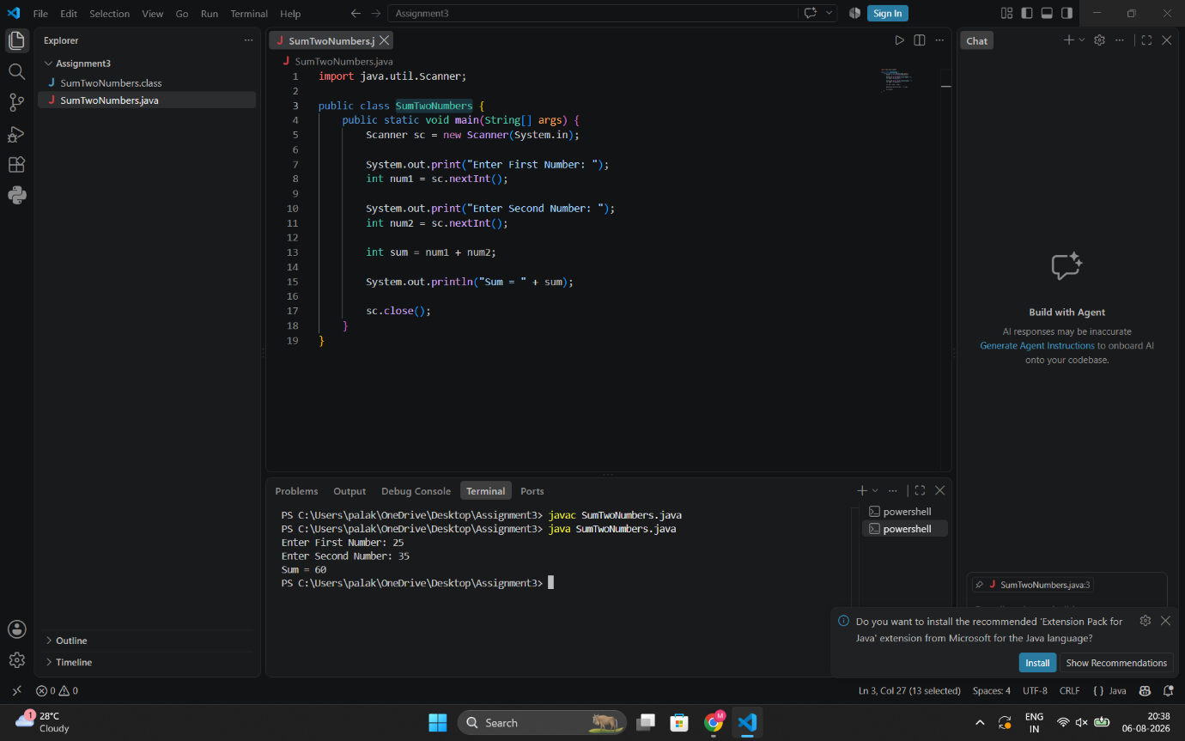

Question 2: Email Address Input
Program:
import java.util.Scanner;

public class EmailInput {
public static void main(String[] args) {
Scanner sc = new Scanner(System.in);

System.out.print("Enter Name: ");
String name = sc.nextLine();

System.out.print("Enter Email: ");
String email = sc.nextLine();

System.out.println("\nStudent Details");
System.out.println("----------------");
System.out.println("Name : " + name);
System.out.println("Email : " + email);

sc.close();
}
}

Output:

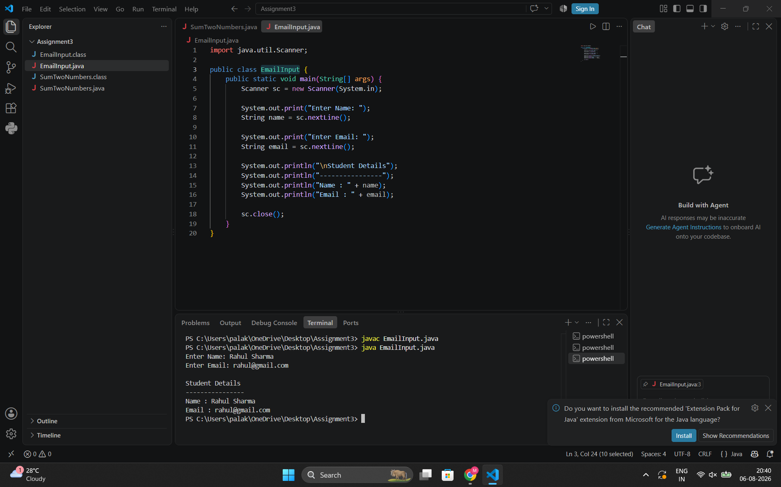

Question 3: Simple Interest Calculator
Program:
import java.util.Scanner;

public class SimpleInterest {
public static void main(String[] args) {
Scanner sc = new Scanner(System.in);

System.out.print("Enter Principal Amount: ");
double principal = sc.nextDouble();

System.out.print("Enter Rate of Interest: ");
double rate = sc.nextDouble();

System.out.print("Enter Time (Years): ");
double time = sc.nextDouble();

double si = (principal * rate * time) / 100;

System.out.println("Simple Interest = " + si);

sc.close();
}
}

Output:

